PROJECT PROPOSAL WITH STRATEGIES | USER INTERFACE DESIGN - D279

Hamza Sangare

**A.1. Necessary Website Functionality and Micro-Interactions**

To meet both stakeholder and audience expectations, the website should include the following micro-interactions and functionality, each tailored to address specific needs:

**Accessibility features:** by ensuring proper contrast, font sizes, and keyboard navigation, the website will adhere to accessibility standards.

* Stakeholders need: by adhering to accessibility standards, the website can reach a broader audience, including people with disabilities, which aligns with the goals of increasing traffic and consultation on the site.
* The audience needs: Most pet owners, including those with disabilities, rely on accessible websites and easy-to-find information about their pet care. Proper contrast and font sizes make the content readable for users with visual impairments. Enable keyboard navigation will also ensure that users who cannot use a mouse can still navigate the website.

**Search engine optimization:** to rank the website on the first page, it must be optimized for search engines for keywords like “pet consultation.” and “pet care.”

* Stakeholders need: An improved search engine optimization will help the website achieve its goal of reaching 100,000 new visitors within one year by increasing traffic from search engines.
* The audience needs: By ranking high on search engine results, the website can be more visible for pet owners searching for specific advice or services online or consultation.

**Contact form:** This will ensure that user information, such as pet owner name, phone number, email, time zone, and pet details, such as pet name, type, and age, are collected for consultation requests.

* Stakeholders need: the contact form will ensure that the pet company collects all the information required to schedule a consultation, which will help them achieve their goal of 150 new consultations within a year.
* The audience needs: users seeking personalized advice about their pets need an easy way to request a consultation. The contact form will allow users to provide necessary details in one place.

**Micro-interactions:**

Form validation with real-time feedback: This ensures that users get real-time feedback while filling out the forms; the form should indicate errors or missing fields.

* Stakeholder need: by ensuring that forms are filled out correctly, the company can rest assured that they will not receive an incomplete form or incorrect consultation request, leading to efficient scheduling.
* The audience needs real-time feedback that helps users correct their typos immediately, reducing frustration and improving their overall experience.

Smooth transitions between pages when users navigate the website.

* Stakeholder need: a good user experience encourages visitors to stay on the website longer, increasing the chance of reaching out for a consultation.
* The audience needs smooth transitions to create a more pleasant browsing experience, helping users explore the website to find the necessary information.

Hover effects on buttons and links.

* Stakeholder need: making the website more engaging will encourage users to act, such as clicking on a request for a consultation button or contacting the company.
* The audience needs: adding hover effects provides visual feedback, making it clear which elements on the site are clickable, improving the site's overall usability.

**A.2. Content for new page based on user persona**

User persona: the “Bird Owners Page.”

The content for the new bird page:

* Relational needs of birds: Birds need social interaction and mental stimulation to maintain their well-being.
* Signs of depression in birds: symptoms of bird depression can be listed, like changes in vocalization, irritability, and reduced appetite.
* Tips for bird care: direct advice on environmental enrichment, socialization, and toys.
* Consultation a “Call-To-Action”: encourage bird owners to schedule a consultation with the company “Pexpert” for in-depth and more related advice.

This content aligns with the user persona. Bird owners often use desktop devices, so the content should be easily read and detailed on a large screen. The content directly addresses their concerns, ensuring their pet's well-being. And finally, the call-to-action aligns with their need for expert advice.

**A.3 Existing content or redevelop**

Cluttered layout: the current website has a disorganized layout that makes it difficult for users to find information; the links aren’t obvious, the title and the logo need to be redeveloped, the navigation bar as well, and the footer needs to be integrated for users to access information their need quickly.

* This fails to meet stakeholder needs. A disorganized layout reflects poorly on the company and reduces trust and engagement. Stakeholders want a user-friendly website that encourages them to find content and request consultations. A cluttered layout doesn’t serve this goal well, which makes it harder for users to take action.
* This also fails the audience’s needs. Users, particularly first-time visitors, need a straightforward layout that is easy to navigate and find the information they seek. A cluttered layout creates frustration and may lead users to leave the site unsatisfied and will evenly never go back.

Non-responsive element: the current website has elements that do not function when clicked. It should be redeveloped to ensure functionality across the whole site.

* This fails to meet the audience’s needs. Users expect all interactive buttons to function seamlessly. Non-responsive elements cause poor user experience, leading to frustration and a lack of trust in the website and the company.
* This fails stakeholder needs. Stakeholders want a fully functional website that will provide a positive user experience. However, non-responsive elements will cause the company to lose consultation opportunities and hinder the company’s brand and reputation. This must be fixed to achieve the goal of 150 new consultations.

Outdated or missing information: any content that is no longer relevant or accurate should be removed or updated.

* This fails stakeholder needs. The stakeholders want to provide trustworthy information on pet care to build trust and credibility with their audience. Missing or outdated information undermines this goal, leading to potential customer loss.
* This fails the audience’s needs. Pet owners rely on up-to-date and accurate information to care for their pets. An outdated and missing information will lead to confusion or harm to their pets if they follow incorrect advice.

**A.4 Visual Sitemap**

Below is the visual sitemap for the new Paradigm Pet Professionals website

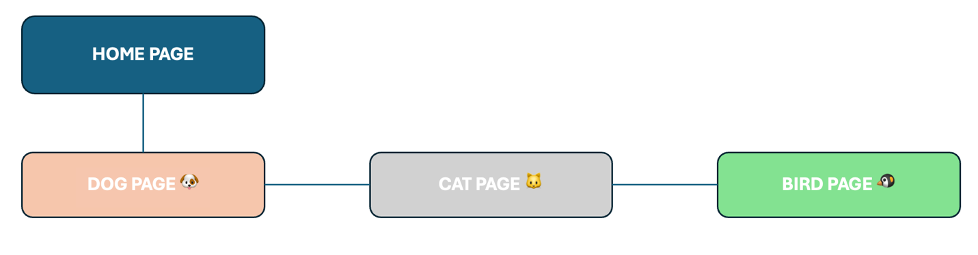

Sitemap structure:

* Home Page
* Existing pet pages:
  + Cate Page
  + Dog page
* New page:
  + Bird page

**A.5 How does information architecture meet audience and stakeholder needs?**

A clear hierarchy, such as the sitemap, provides a clear structure and makes it easy for users to navigate and find the necessary information.

These new pages and updated content will be designed to improve search engine rankings, helping the site reach its goal of 100.000 new visitors.

The design will adhere to accessibility standards, ensuring all users, including those with disabilities, can effortlessly use the site. The content will be custom-fitted to the needs of a specific user persona, providing a personalized experience.

**A.6 Primary and secondary navigational elements**

Here is the primary navigation:

* Home
* Cats
* Dogs
* Birds
* Contact Us

Secondary navigation:

* About Us
* Resources
* Consultation Request

These primary and secondary navigations align with the audience and stakeholder expectations. The primary navigation directly links to the most important pages, such as pet-specific pages, ensuring users can quickly access the information they need. The secondary navigation will provide additional resources and information about the company, supporting the stakeholder’s goal of building trust and credibility.

**Part B: Mid-Fidelity wireframe for the home page**

Below is the mid-fidelity wireframe for the home page, designed specifically for a desktop website:

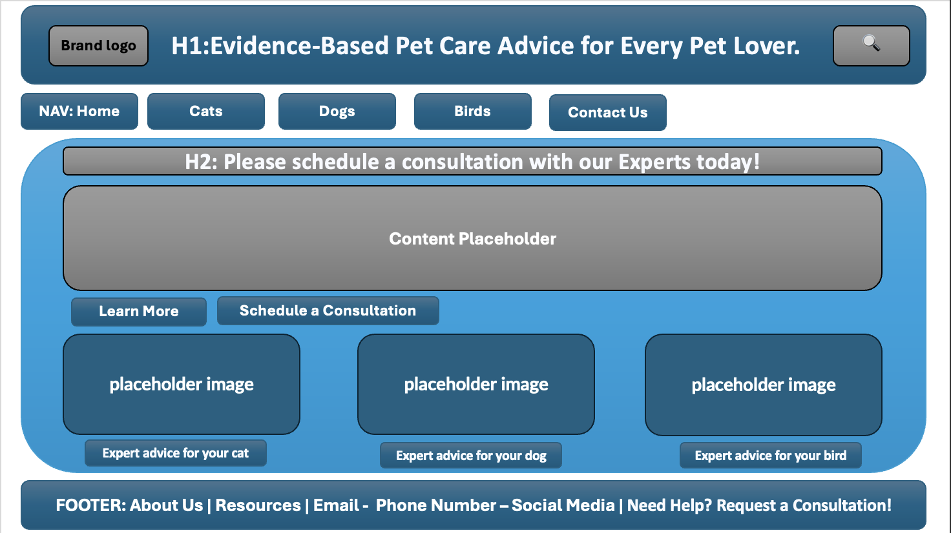

**Part D: Interactive Desktop Prototype**  
  
  
[**https://westerngovernorsuniversity-my.sharepoint.com/:p:/g/personal/isanga4_wgu_edu/EQMk_rf0GQFAoY5FfJii2coBmZhlCSqcNHDjVPZTVC25bg?e=gTPffK**](https://westerngovernorsuniversity-my.sharepoint.com/:p:/g/personal/isanga4_wgu_edu/EQMk_rf0GQFAoY5FfJii2coBmZhlCSqcNHDjVPZTVC25bg?e=gTPffK)